# Azure Student Account Activation

Instructions for activating Azure Student Account for the "Containers and Clouds" course @ SoftUni

|  |  |
| --- | --- |
|  | With the "Azure for Students" **subscription** that you have, you get **$100 credit** or 12 months (which is first exceeded) **without** requiring a credit card. If you **exhaust your available credits**, your **Azure** **subscription will be disabled** and you should upgrade.  For this reason, you should **save your credits**. To do this, make sure that you keep your **Azure resources** active for **as little time as possible**, e.g., **delete the created resources** when you don't need them anymore. |

## Explore Azure Portal

Azure Portal is a **single portal** to access and **manage all your apps**. You will need it when uploading and working with **apps in** Azure.

|  |  |
| --- | --- |
|  | If you have a personal Azure account, **don't** use the phone number, that is associated with it, when activating your Azure student account! Instead, use another phone number in order for your activation to be successful. |

### Activate Azure Student Subscription

Before we do anything with Azure, you should **activate your student subscription** to be provided with **free resources from Azure**.

To do this, visit Azure Portal on <https://azure.microsoft.com/en-us/free/students> and click on the **[Start free]** button:

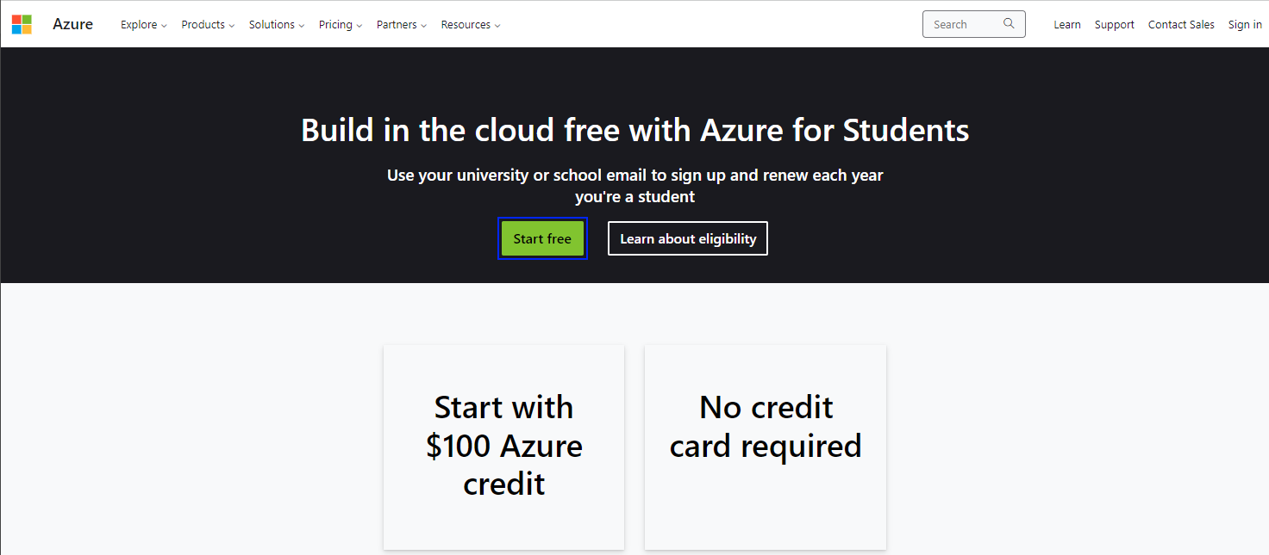

## If You Have Another Azure Account

In case you have another Azure account, when you click on the **[Start free]** button, a login page will open and you will see it there. You should click on the **Sign in with another account** link:

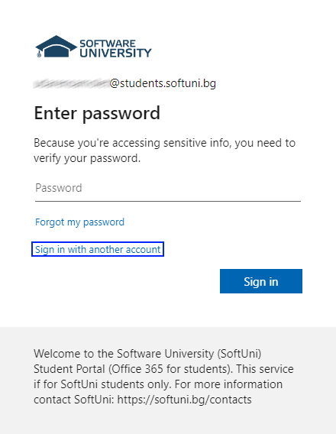

Choose **Use another account** from the displayed **options:  
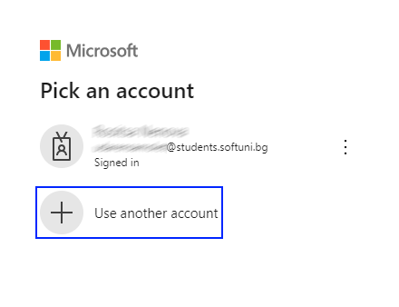**

Type in your **SoftUni DevOps student email** and click on the **[Next]** button:

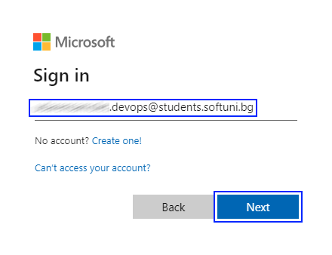

You will be asked to provide your password. Type it in and click on the **[Sign in]** button:

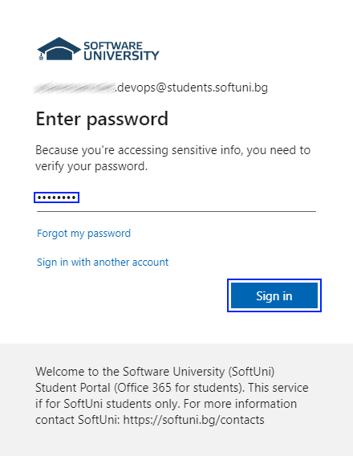

After that, you will be asked to create a new password. After you create your new password, click on the **[Sign in]** button again:  
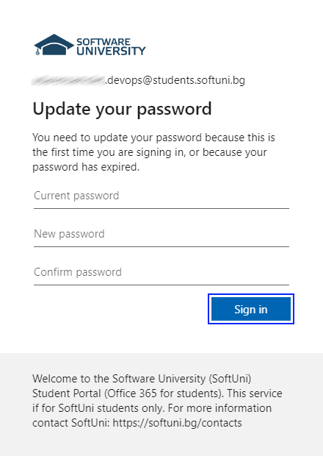

Then, you will be asked for some more information. Click on the **[Next]** button again:

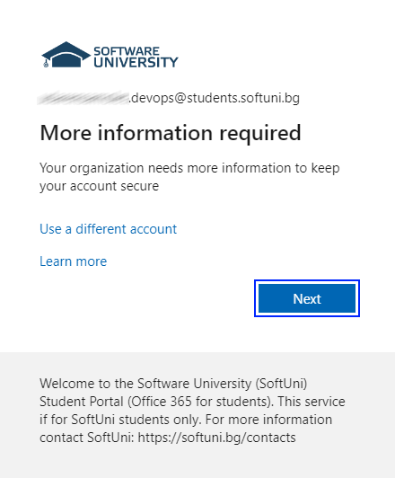

You will be asked for a phone number.

**NOTE: Remember that you should use a different phone number from the one you have used for your other Azure account!**

You will receive a 6-digit code, which you should enter and click on the **[Next]** button:

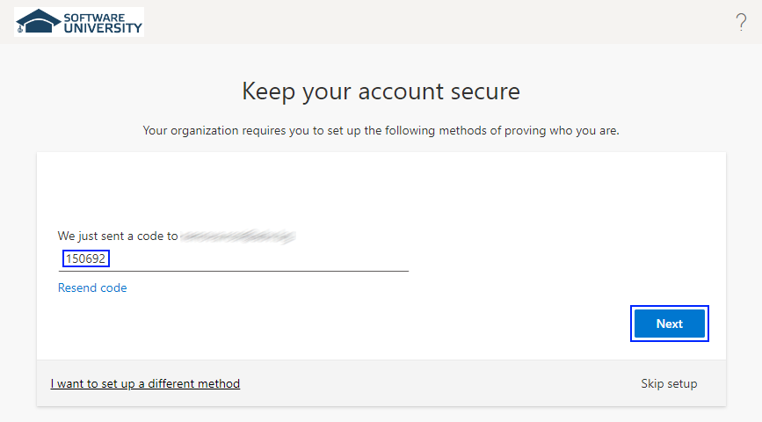

After that, you should see a success message. Click on the **[Done]** button:

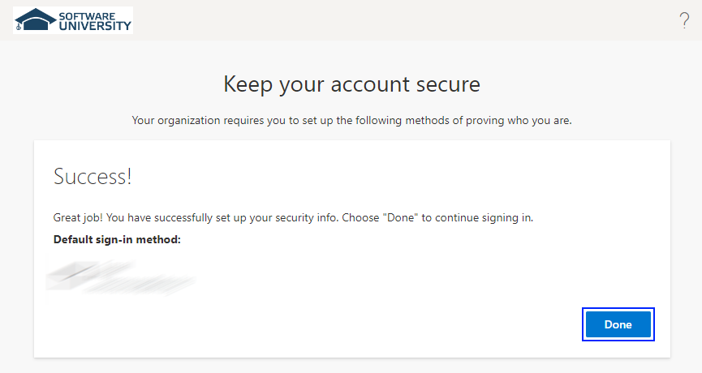

You will be asked for some more details. Provide the requested information. Please note that your names and your e-mail will be already present in the form – **do not change them!**

**Don't fill in anything in the School name input field!**  
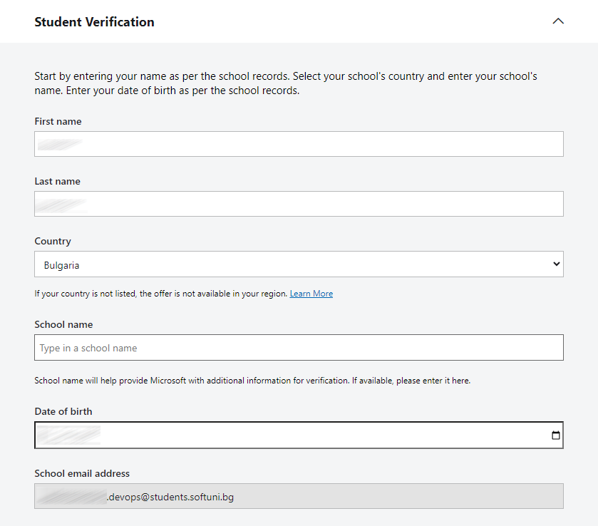

You may be asked to solve a puzzle to prove you're human – solve it and click on the **[Verify academic status]** button:

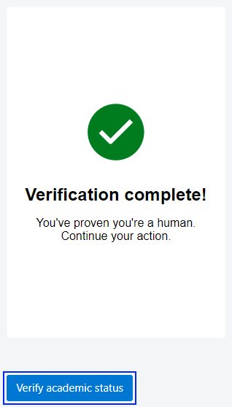

After that, a new window will appear and you will be asked to enter your **first** and **last** names, your **address**, you **phone number** and a **second** **e-mail**.

**IMPORTANT NOTE: Please keep in mind that the phone number and e-mails should be different from the ones registered to your other Azure account!**

**After confirming your personal information**, you will be **redirected** to the **home** page of the **Azure Education Portal**.

When **login is successful**, you will see the **main page of the** Azure EducationPortal:

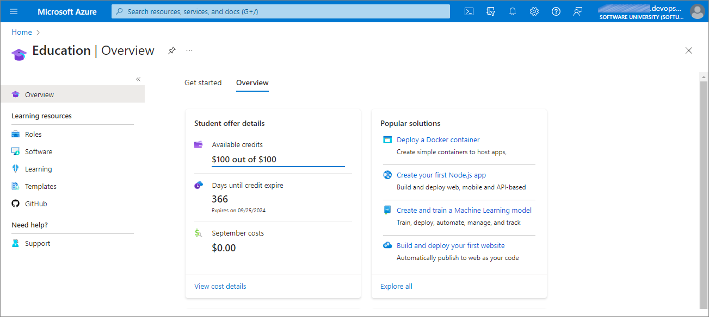

Congratulations! You have successfully activated your student Azure account!

## If You Do Not Have Another Azure Account

If you don't have an Azure account already, when visiting the sign-in page, you should see the form from the image below. Click on the **[Next]** button

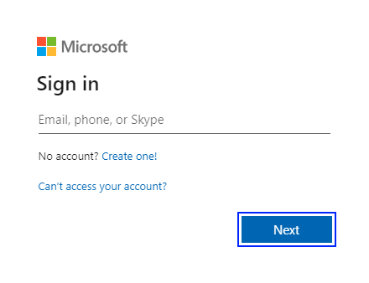

Input the password that you have been provided with and click on the **[Sign in]** button:



You will be asked to create a new password. Type the old one and the new one and click on the **[Sign in]** button:



After that, you will be asked for additional information – you should type in your **phone number**:

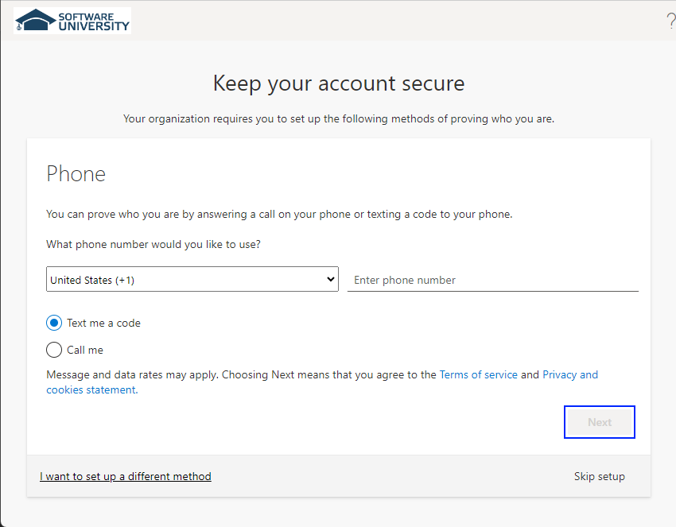

You will receive a 6-digit code, which you should enter and click on the **[Next]** button:



After that, you should see a success message. Click on the **[Done]** button:



You will be asked for some more details. Provide the requested information. Please note that your names and your e-mail will be already present in the form – **do not change them!**

**Don't fill in anything in the School name input field!**  


You may be asked to solve a puzzle to prove you're human – solve it and click on the **[Verify academic status]** button:



After that, a new window will appear and you will be asked to enter your **first** and **last** names, your **address**, you **phone number** and a **second** **e-mail**.

**After confirming your personal information**, you will be **redirected** to the **home** page of the **Azure Education Portal**.

When **login is successful**, you will see the **main page of the** Azure EducationPortal:



Congratulations! You have successfully activated your student Azure account!